Hostopia Internal Project 1: Simple Boardroom Booker
Iteration # 1

Created: 2004-01-07
Last Revised: 2004-01-07

Authorized signature #1: ____________________________________

Authorized signature #2: ____________________________________

Released (yyyy/mm/dd): ____________________________________

Table of Contents

Overview Statement 4
Project Manager 4
Goals 4
Revision History 4
User Stories 5
Book the Boardroom 6
Modify a booked event 8
Employee List 9
Click this link to add a new employee 9
Add a new employee 10
Remove an employee 11
Design Considerations 12
Open Issues 13
Sign offs 14
Other information 14
SR&ED information 15

Overview Statement
The purpose of this project is to create a boardroom scheduling interface.

Project Manager
Dirk Bhagat

Goals
- To provide a flexible way to book a boardroom for meetings, seminars, training, etc.
- To access the scheduling interface to view availability of boardrooms
- Create a toggle feature so users can access calendar months with ease
- Generate and manage error messages

Revision History
None

User Stories

Boardroom Booker access should be password protected. That’s why application should start with a Username/Password prompt (page with input fields for username and password). If authenticated, user may proceed to Boardroom Booker. If authentication failed, error page should be generated.

Upon accessing the Boardroom Booker, users should be presented with the current calendar month. Any appointments scheduled are displayed in the appointed day using a 12 or 24 hour clock (with AM and PM), depending on program configuration.
NOTE: First day of the week displayed (Sunday or Monday) is also configurable
There are clickable links, one for each boardroom. Clicking on the appropriate link will display the current boardroom schedule. Number of boardrooms is user-defined in program configuration.

Current Month selected

Boardroom 1 | Boardroom 2 | Boardroom 3

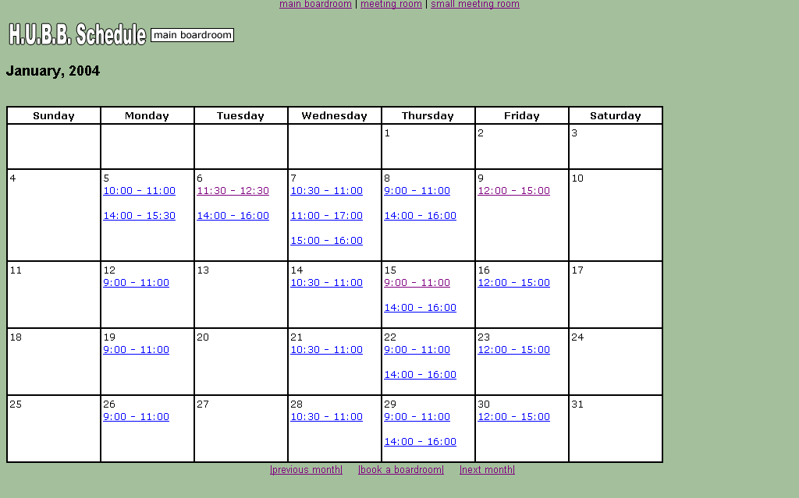
Boardroom Booker
Boardroom 1

Book It!
Current Boardroom selected
A toggle feature will allow users to easily view the Next Month (>) or Previous Month (<).
< January 2004 >
Employee List
- Book boardroom link
- Employee List link

- Users will click the “Book It!” link to book a new appointment
- Users will click the “Employee List” link to access or change employee details

Book the Boardroom

When booking a boardroom, users will be presented with a form where they will fill out certain parameters.

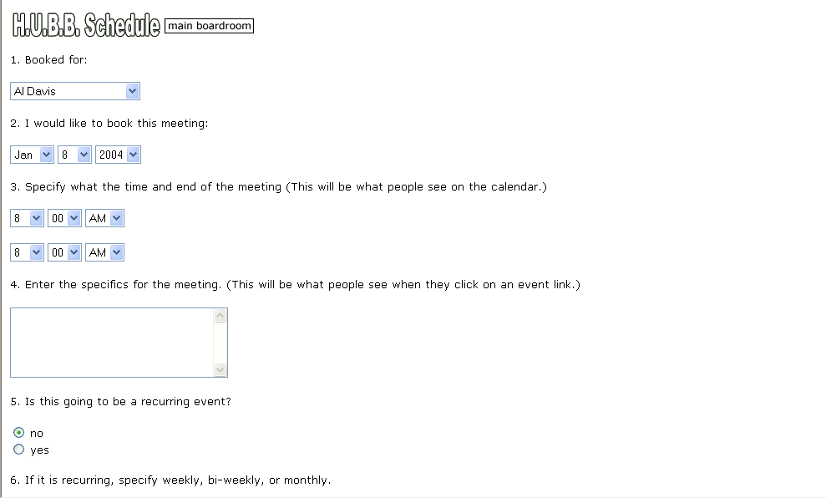
Boardroom Booker
Boardroom 1

Items 1, 2 and 3 contain drop down menus for employees, dates and times.
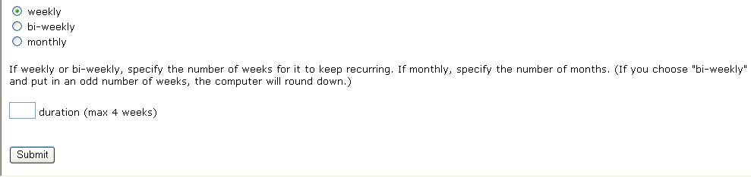

After clicking “Submit”, the system should check for errors, and proper error messages should be displayed.

- Date – Users shouldn’t be able to book a boardroom for a date that has already passed.

- Time – The boardroom must be available for the time specified and times must be viable.
For example: The system cannot accept a time from 8:00 AM to 8:00 AM or 8:00 AM to 7:00 AM.

- Recurrence – If the meeting is a recurring one, the system should check availability for
all appropriate days, whether it is weekly, bi-weekly or monthly. Users
must enter a value in the “Duration” box.
Upon successful submission, users should receive a confirmation message as shown below.

Boardroom Booker
Boardroom 1

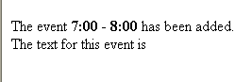
Management Meeting

Clicking a link on the calendar page should display a pop-up window showing booked statistics. Here you should be able to modify the details of the event.
Boardroom 1 | Boardroom 2 | Boardroom 3

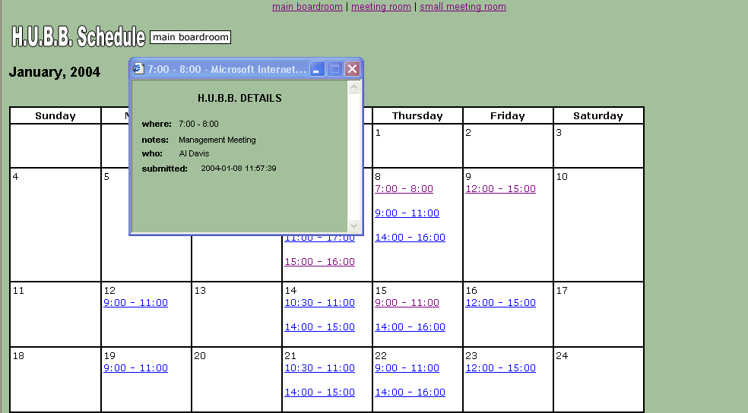
< January 2004 >
Boardroom Booker
Boardroom 1

Book It!
Employee List
–
8:00
When:
7:00
Notes:
Who:
Management Meeting
Al Davis V
Submitted: 2004-01-08 11:57:39
B.B. DETAILS
DELETE

UPDATE

Modify a booked event

When modifying an event, users can click any link on the calendar to view its statistics, make changes or delete. Users should be able to modify the fields for a particular booking, or for the entire occurrence.

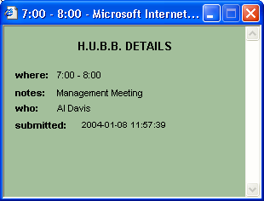
8:00
When:
7:00
–
Notes:
Who:
Management Meeting
Al Davis V
Drop-down
Employee list
DELETE

UPDATE

Apply to all occurrences?
B.B. DETAILS

This option should only appear for a recurring event.

In the case of a recurring event, the user should be able to select any appropriate day. The system should display a message asking the user if they want to allow changes for all occurrences, and if so the system should provision accordingly. This box by default is unchecked and shouldn’t appear if the event is a single one.

For example, if a meeting occurs every week for four weeks and the user deletes it ‘for all occurrences’, all appropriate events should be deleted. Users should receive appropriate confirmation messages. An example is illustrated below.

Boardroom Booker
Boardroom 1

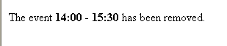

Employee List

The employee list is a list of current employees or contacts residing in the system. This list is accessible for administrating user only. Users will be presented with the current employee list when selecting this link. Here you can add, edit or delete a contact.

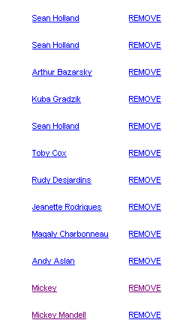
EDIT

EDIT

EDIT

EDIT

EDIT

EDIT

EDIT

EDIT

EDIT

EDIT

EDIT

EDIT

Add a new employee

Click this link to add a new employee

Currently, clicking on the contact (person’s name) will be a “mailto” reference; hence a proper e-mail address should be added when adding an employee. It should be possible to edit the contact’s information in case of a change of address.

Add a new employee

When adding a new employee, users will be presented with the following screen:

- Enter new employee name
(required).
- Enter new employee e-mail
(required).

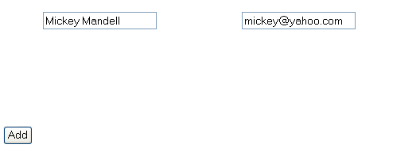

After clicking “Add”, the system should check for a valid e-mail address and produce an error message if the field is invalid. A successful addition should produce a confirmation message.

Remove an employee

Clicking “REMOVE” should:

- remove the contact from the list
- confirm the deletion (i.e. Are you sure you want to delete this contact?), and
- produce a confirmation message

EDIT

EDIT

EDIT

EDIT

EDIT

EDIT

EDIT

EDIT

EDIT

EDIT

EDIT

EDIT

Design Considerations

You may find it helpful to create the following tables:

- EMPLOYEES
- APPOINTMENTS

You may also find it helpful to store the start and end times of appointments as large integers
E.g. a UNIX timestamp, this should help in comparisons etc.

Your PHP code should follow generally accepted principles of design, but specifically:

1. Use an OO approach for this project
E.g. create an employee object, an appointment object, etc.
2. Write comments at the top of function explaining prerequisites, and assumptions, etc.
3. Validate all input
4. There should be no third-party classes or libraries used in the application.

Open Issues

Sign offs

Activity | Date | Signature
Document Created | Jan 2, 2004
Approved by Dir. Of Technology
Assigned to programmer(s)
Peer Review
Passed Formal testing
Scheduled release date
Released
Passed post-release testing

Other information
Programmer(s):
Length of time spent by Programmer (days):
Peer review conducted by:

Notes:

SR&ED information

Is this project eligible? Y N

What is the scientific/technological advancement?

_____________________________________________

_____________________________________________

_____________________________________________

What is the scientific/technological uncertainty?

_____________________________________________

_____________________________________________

_____________________________________________

What is the scientific and technological content?

_____________________________________________

_____________________________________________

_____________________________________________

